**DAR ES SALAAM METROPOLITAN DEVELOPMENT PROJECT-PHASE 2 (DMDP 2)**

**(IDA CREDIT NO. 7478 - TZ)**

**PROVISION OF CONSULTANCY SERVICES FOR THE DESIGN, IMPLEMENTATION, AND UPDATING LOCAL GOVERNMENT SOLID WASTE MANAGEMENT SERVICE FRAMEWORK AND DELIVERY SYSTEM IN DAR ES SALAAM UNDER THE DMDP 2**

**TERMS OF REFERENCE**

# Background.

The Government of Tanzania (GoT) through the President’s Office – Regional Administration and Local Government (PO-RALG) is planning to address Dar es Salaam’s complex urban issues, major infrastructure deficits and institutional strengthening to support improved urban management through Dar es Salaam Metropolitan Development Project – Phase 2 (DMDP 2). The World Bank-financed Dar es Salaam Metropolitan Development Project – Phase 2 (DMDP 2) is in the initial stages of implementation. The PO-RALG Project Coordination Team (PCT) is responsible for overall implementation and coordination functions for the project, which also involves national agencies and the Project Implementation Team (PIT) in five Dar es Salaam Local Authorities (DLAs). PO-RALG wishes to engage a consulting firm to support the PO-RALG PCT and the DLA PIT on implementation support and capacity building for DMDP 2.

Component 2 of the DMDP 2 Project aims at developing an integrated solid waste management system for Dar es Salaam, providing infrastructure and services for safe handling, transport and disposal of waste, as well as sorting and processing of recyclables, composting and other technologies that aim to reduce reliance on landfills and contribute to the reduction of greenhouse gas emissions. It will also strengthen the institutional, regulatory and financing framework and capacity to deliver these services.

The project will finance the construction of solid waste facilities that will provide services shared by the Dar es Salaam Local Government Authorities. An inter-municipal institution will be established under the project that will have responsibility for operating these shared facilities[1]. Investments will include landfills with landfill gas capture technologies; centralized facilities for waste sorting and treatment; and waste transfer stations, reducing transport costs and GHG emissions. The location, number and capacity of facilities and types of treatment technologies will be determined based on a technical assessment using transport modelling, technology assessments, and site assessments with the aim at identifying a cost-effective, environmentally and socially acceptable integrated system that can serve Dar es Salaam into the future[2]. Closure of dumpsites will include livelihoods program for those informal waste pickers working on the dumpsites.[3]

## **Project context**

Dar es Salaam is a coastal city in Tanzania situated along the Indian Ocean. It covers an area of 1’393km2 and has a population of about 5.3 million people in 2022. Politically and administratively, the city is divided into five local government authorities of Dar es Salaam City Council (formerly Ilala Municipal Council) (DCC), Ubungo Municipal Council, Kinondoni Municipal Council, Temeke Municipal Council and Kigamboni Municipal Council. DCC is the governing body of the city and the prospective entity responsible for the development and execution of the project.

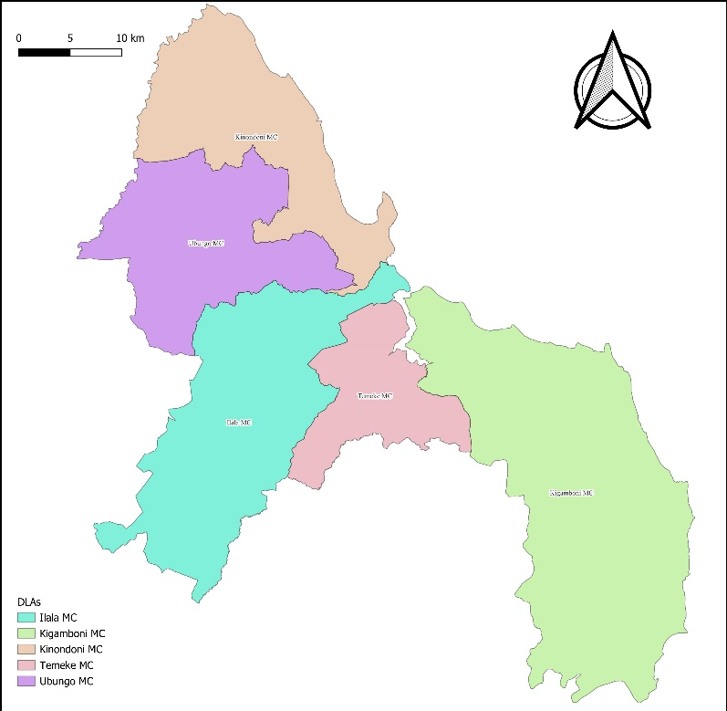Dar es Salaam produces an estimated 5,300 tons of waste per day. With an estimated waste generation rate of almost 1 kg per person per day, Dar es Salaam generates more waste than similar Cities in Africa. Approximately 75% of the waste generated in Dar es Salaam is domestic waste. The waste has a significant fraction of organic waste and appears to have a low calorific value with regard to potential waste to energy proposals[4].

The Dar es Salaam Local Authorities (DLAs) are mandated and responsible for providing environmental cleaning and solid waste management services in the city. The DLAs have adopted a decentralized model of waste management, outsourcing private companies and community-based organisations (CBOs) for solid waste collection and environmental cleaning services. Despite the involvement of private contractors enhancing efficiency and quality of the environmental cleaning and solid waste service in the city, the DLA continues to grapple with several service gaps and challenges.

In light of the challenges above, Component 2 of the DMDP 2 project intends to develop an integrated solid waste management system for Dar es Salaam, providing infrastructure and services for the safe handling, transport and disposal of waste, as well as sorting and processing of recyclables, composting and other technologies that aim to reduce reliance on landfills and contribute to the reduction of greenhouse gas emissions. It will also strengthen the institutional, regulatory and financing framework and capacity to deliver these services.

**Inter-municipal Solid Waste Management Institution:** A study undertaken in 2021 to complement an investment program under the Dar es Salaam Metropolitan Development Project Phase 2 assessed the feasibility of establishing an inter-municipal organization to plan, coordinate and manage solid waste activities in Dar es Salaam. The study, coordinated by an inter-municipal, regional and national government technical working group, undertook a detailed technical, financial, institutional, and legal review of options based on common practice worldwide and examples in other sectors in Tanzania.

The study concluded that as part of the complementary investment program under Dar es Salaam Metropolitan Development Project Phase 2, the establishment of an organization that could provide Dar es Salaam-wide planning and regulation of LGA solid waste services and deliver those solid waste services shared by the various municipalities including waste transfer, transport, recycling facilities and disposal, would result in: (i) improved service quality and consistency of services among municipalities; (ii) improved efficiency of services through professionalization of services and service standards; (iii) improved transport logistics and related cost efficiency and service quality; (iii) encourage economic growth and jobs; (iv) enhanced involvement, efficiency and effectiveness of the private sector through improved contractual environment and scale; and, (iv) higher organizational efficiency due to allocation of more specialized staff, benefits of having an integrated organization and commercialization of services.

A new organization would be established to provide overall planning, regulation of services and coordination, and to deliver solid waste services that would be shared by all municipalities in the region. The organization would be comprised of: (i) an inter-municipal association made up of the 5 municipalities in Dar es Salaam which would be the owner of the services and supervise and regulate the public company; (ii) a public company which would act as a management entity that would invest, own and manage those solid waste management infrastructure and services shared among municipalities. It would have powers to raise revenues predominantly through charging fees and tariffs for their services to local governments, and other waste producers and operators, and through revenues from resource recovery. It could also contract out services to the private sector that would operate the key infrastructure, and in the case of transport could invest in equipment for that purpose.

**Local Government Services**: The Dar es Salaam Local Government Authorities (DLAs) would carry out those services (e.g., services related to waste collection and cleaning, decentralized resource recovery) that are more dependent on local proximity and with more social involvement. The study proposed the following organization of services of the local government services vis-à-vis the services of the Inter-municipal Solid Waste Management Organization.

**Table 1: Current and Proposed Services**

| **Current Organization of Local Government Services** | **Proposed Organization of Local Government Services** | **Future Services of Inter-municipal Organization** |
| --- | --- | --- |
| Primary and secondary collection of municipal waste and transport to disposal site | Primary and secondary collection of municipal waste from households to transfer stations or directly to sanitary landfill. | Municipal Waste Disposal |
| Municipal waste disposal (dumpsite operated through Dar es Salaam City Council) | Collection and transport of municipal waste institutions / commercial/ industrial to transfer stations or directly to sanitary landfill. | Waste Transfer |
| Street Sweeping /Drain cleaning | Collection and transport of market waste to landfill or composting plant | Centralized waste sorting, composting or other resource recovery facilities. |
| Market Waste Composting (in Kinondoni Municipal Council) | Collection and transport of sorted waste to centralized resource recovery facilities. | Waste transport from transfer station or centralized resource recovery facilities to disposal site. |
|  | Street sweeping/drain cleaning |  |
| Beach cleaning |
| Cutting of the grasses and pruning along roads |
| Cleaning of public cemeteries. |
| Collection and disposal of animal carcasses. |
| Cleaning of areas for special events |
| Cleaning and maintenance of public bathrooms |
| Removal and management of bulky waste |

In addition to these identified by the study, there are other services undertaken in the local government jurisdiction through informal and formal actors, with varying involvement of the government. For example: (i) collection of recyclables; (ii) construction and demolition waste; (iii) community material recovery facilities; (iv) household composting; and, (v) drain cleaning

**Gaps in the Services Framework and Delivery System:** Currently, not all the services provided (or to be provided) in the jurisdiction of the DLAs are fully recognized or legitimized and do not have a well-defined ***“Services Framework”*** that provides clear approaches as to how or by whom, each service is administered or governed; operated and financed. This lack of definition limits their effectiveness, efficiency, and coverage.

Additionally, the services lack systems to ensure effective delivery. An effective ***“Service Delivery System”*** should consider the following elements: (i) *Service planning* including Strategic Planning, Service Design, Service Programming and analysis of performance; (ii) *Service execution* including operation of the service, attending emergencies and supervision*;* and (iii) *Service Control* including monitoring of service completion, regulatory compliance, and consumer attention.

Through the consultancy, a “Services Framework” and corresponding “Service Delivery System” will be defined and elaborated. A Services Plan to establish these will be developed and implemented in collaboration with the DLAs.

The consultancy aligns with other ongoing DMDP 2 studies, including a study on legal and institutional reform that would establish the Solid Waste Inter-municipal Institution, and studies for the design of the shared infrastructure. Potential changes stemming from these studies should be closely monitored and incorporated into the consultancy's findings and actions.

# Objectives

The objective of this consultancy is to Develop a Services Framework and to Implement a Service Delivery System for Dar es Salaam Local Authorities.

## Within the objective of this consultancy service, the general scope of work is:

* Assess the current solid waste and cleaning services in each of the 5 local governments in Dar es Salaam, reviewing their performance; characterizing the administration, operational arrangements, and financing and identifying gaps or bottlenecks.
* Outlining a Services Framework for services that will be provided in the future by the 5 local governments.
* Assess options and feasibility of administration, operational and financial models for the Services Framework based on a detailed technical, institutional/legal, cost of service assessment.
* Designing a services plan for the 5 local governments including a Services Framework and Service Delivery System.
* Developing enabling documents for the Services Plan including legal documents, fee collection and billing system, standard operating procedures, communications plan, and information management plan.
* Developing equipment specifications to support the Services Plan.
* Support the adoption and implementation of the plan through coaching, training both theoretical and on the job training, and provide day-to-day management advice to the 5 local governments throughout the implementation.
* Work jointly with 5 local governments to achieve the targets defined by performance indicators.

# Scope of the Assignment

**3.1. Task 1: Baseline Data Collection**

The consultant will work with PORALG, the local government authorities, the World Bank and other stakeholders to gather relevant information for the study.

**Document and Data Review:** They will review, evaluate the quality and catalogue the information for future use. This will include but not limited to:

* Previous assessments of the solid waste system.
* Census and other data and surveys on population, buildings, land use.
* Studies projecting urban growth in Dar es Salaam.
* GIS and other data on buildings, activities and other sources of information to understand waste generators.
* Equipment and infrastructure owned by the municipality and those used by contractors.
* Municipal and contractor data on waste collection and cleaning coverage, performance.
* Existing waste management plans and strategies.
* Overall strategies, policies, and plans.
* Municipal by-laws.
* Waste specific regulations and standards and licensing.
* Copies of contracts.
* Data on solid waste services.
* Budgetary, economic, and financial plans and programs
* Waste characterization and generation studies including those undertaken for the DMDP Phase 2 project.
* Geographic and quantitative data on urban public space that may be subject to cleaning services including public spaces, beaches, roads etc.

**Conducting a Survey of Solid Waste Services:** The consultant will develop a survey in order to understand how the services are performed, their satisfaction and to better understand gaps. This should include surveys of the DLA staff, and various service providers. It also should survey on a sampling-basis consumers, building on previous services undertaken and supplement them geographically, by services, costumers or contractors. The survey should follow good practice and methodologies to collect representative data and be useful for Task 2 of the assignment.

**Cost survey for Investment, Operation of a Proposed Solid Waste System:** The consultant will need to have accurate and updated estimates of the costs of establishing and operating the solid waste services in order to identify cost effective solutions. The consultant can take advantage of earlier studies under DMDP Phase 2 but will be expected to have creditable and verifiable sources of costs using recent works, quotes from suppliers, updated fuel and labour rates. It should cover all capital expenditures (works, equipment, vehicles,) and operational expenditures (fuel, labour, vehicle operational costs) for the services to be managed by Dar es Salaam Local Government Authorities. They should create a database with numbers, dates, sources for use and updating throughout the consultancy.

**3.2. Task 2: Assessment of Solid Waste Services in the 5 Municipalities**

The purpose of this phase is for the Consultant to map and assess the existing services related to solid waste and cleaning services in the jurisdiction of the five Dar es Salaam local governments.

Particular activities under this task are to:

**Summarize the Detailed Status of Services** in solid waste and cleaning in Dar es Salaam and their current performance: The consultant will describe the existing services provided, the arrangements for the provision of services, the quality and coverage of the services. Specifically, the consultant will undertake the following:

*Identify services:* Defining the range of each existing solid waste and cleaning services (both formal and informal) provided within each local government jurisdiction. The consultant should be inclusive and include all services for waste management and cleaning provided by the municipality, contractors, private sector (informal and formal), NGOs and CBOs. The consultant will list these services, providing a summary of each along with basic responsibilities. The list will form a basis for future analysis as part of the Services Framework and will need to be agreed with the client before moving forward.

*Assess Service Performance:* The consultant will, based on available data and information and survey from Task 1, provide detailed data and where available geographic information preferably by ward on the service coverage, frequency, satisfaction, and other elements affecting the quality of each service. As previous studies have shown service quality to have a strong geographic dependence (Central Business District verses rural areas, high vs. low density settlement, informal vs. formal settlements, commercial vs. residential) and dependence on access and road condition, the consultant should disaggregate the service performance based on these different factors. Where detailed data is not available (in the case of informal or community-based work), the consultant will make an effort to gather qualitative information based on interviews and discussions with various groups.

### **Assessment of Existing Service Framework:** The consultant shall conduct an assessment of the service framework for the identified existing environmental cleaning and solid waste services in the five Dar es Salaam local governments and identify gaps or challenges.

*Administrative and Organizational Models:* Conduct a comprehensive assessment of the existing oversight by local governments for overall and for each of the identified solid waste management services. Specifically, the consultant shall assess:

Overall Administration:

* + - * The human resources allocated to the departments/units involved in solid waste and cleaning services including personnel inventory, their roles, responsibilities, and qualifications. Staff workloads shall be evaluated to determine alignment with responsibilities and overall service delivery requirements.
      * Identify the legal basis for local government mandate and summarize the laws, by-laws and regulations that apply.
      * Review staff qualifications, the clarity of responsibilities, the availability of job descriptions for each position, and the understanding and implementation of standard operating procedures (SOPs) by Solid waste and Sanitation unit staff.
      * Review the existing local government structure and assess the structure of the solid waste unit, environmental and natural resource units, and other departments supporting solid waste and environmental cleaning services. The roles, functions, and reporting relationships should be established.
      * Evaluate the decision-making processes within these departments, including the level of authority, accountability, reporting and coordination. Assess the level of coordination and collaboration among different departments involved in SWM, including inter-agency cooperation.
      * Identify gaps and evaluate the efficiency and effectiveness of administrative processes within the local government and solid waste unit, including contract payment arrangements, permit issuance, data management, and reporting systems.

Administration of each service:

* Identify the local government role in the service (e.g., direct provision, contractual, licensing, regulatory, passive tolerance, no relationship).
* Identify the organization structure for the governance of the service by local governments.
* Identify legal basis for the role of the local government in the particular service.
* Identify any local government staffing, job descriptions, procedures or protocols dedicated to the service.
* Identify gaps and evaluate the efficiency and effectiveness of administrative processes within the local governments.

*Operational model:* For each existing service, the consultant should assess the operational model, specifying, for example, services that are directly managed by DLAs, licensed to CBOs or private companies, contracted out or provided entirely by the informal or private sector.

Technical aspects of service delivery:

* + - * Identify and evaluate the approach/technology used, coverage and effectiveness of the service.
      * Review condition, appropriateness and quantity of equipment used for delivery of services in different contexts (informal vs. formal, road conditions etc.).
      * Review inventory, operation and maintenance arrangements, procedures and protocols.
      * Identify gaps and bottlenecks related to the technical approach.

Licensing, Contracting and Supervision Arrangements:

* + - * Identify existing service licencing and contracting arrangements for core services in each of the 5 local government authorities in Dar es Salaam.
      * Evaluating the terms and conditions of existing contracts, including service level agreements, performance expectations, and payment arrangements. The ccontract duration, and other contractual specifications (i.e., specific contract and general contracting) should also be established.
      * Assess the policy and regulatory framework on service provider procurement processes and contracting and licensing; The consultant shall assess the procurement processes and procedures employed by each DLA for services identified. Specifically, the consultant shall evaluate the current regulatory framework governing the procurement processes i.e., The Public Procurement Act (PPA), Public Private Partnership (PPP) Act and any other relevant regulations.
      * Additionally, the consultant will identify key government units responsible for overseeing the procurement.
      * The consultant would analyse tender documents and procedures, including tender costs, content of the tender documents, and eligibility/qualification requirements for bidders.
      * Review the supervision arrangements and protocols.

Service Standards:

* + - * Assess the service standards and Performance evaluation mechanisms employed by DLAs within existing services including those subjects to contracting arrangements to determine if current contracts effectively evaluate service delivery, cost-efficiency, and environmental impact.
      * Identify operational and contractual challenges encountered in service delivery for existing services including waste collection, transportation, and disposal activities.
      * Review existing bylaws to identify gaps and inconsistencies within the context of the newly established solid waste management framework, and assess their ability to support services.

*Financial Model:* The consultant will review the current budget and tariffs applied to municipal services as well as prices applied to services that are run completely or in part by the private sector, to understand the financial flows and to identify gaps for improvement or adjustment.

Municipal Budget Analysis

* Conduct a comprehensive assessment of the financial resources allocated to municipal solid waste and cleaning services, including budget allocation, revenue generation, and expenditure patterns set by each of the five local government authorities in Dar es Salaam.
* Assess the indirect budget contributors to environmental cleaning/waste management services Identify and assess the contributions of other departments or units to SWM services, including Shared services (e.g., human resources, finance, procurement).
* Assess the contribution of Refusal collection charges (RCC) and other sources of revenue to the Municipal environmental cleaning/waste management budget e.g. payment terms, and revenues received.
* The consultant will employ an eclectic methodology to ensure the accuracy and comprehensiveness of budget data. Among others, the consultant can Request and Collect Data to obtain detailed budget breakdowns from each local government, specifying revenue sources, expenditure categories, and allocation to SWM services. Conduct Stakeholder Interviews with finance and budget officials to clarify budget information, identify potential discrepancies, and gain insights into budgetary processes. Or Facilitate Data Consolidation in term of workshops with relevant departments to reconcile budget data, address inconsistencies, and ensure a shared understanding of the financial landscape.
* Breakdown of expenditures by activity or service (e.g., waste collection, disposal, recycling, public cleaning).
* Define the Percentage of the overall municipal budget allocated to SWM services. The consultant shall identify the total budget plan and actual budget allocated to the sanitation and solid waste Unit.
* Discuss with contractors and CBOs on their budget and resource outlay vis-à-vis the municipal budget.
* Discuss with informal or formal private sector actors providing the services on the municipal resources provided to these services.
* Identify based on the analysis, gaps in budgeting and financing of different services qualitatively and quantitatively.

Tariff and Fee System Review

* Identify and assess fees for payable services and tariff arrangements. The consultant will analyse the existing tariff structure for current list of services including those executed by local governments, private sector, NGOs, informal sector or combination thereof.
* Identify, characterize and evaluate the approach to billing of each of these services, assessing its level of maturity and performance.
* Identify and characterize the current approach to setting these tariffs and fees, including the degree it considers or responds to service costs, standards and where relevant private sector market.
* The analysis should provide an understanding of the variations in fees or tariffs charged formally or informally in different geographic areas or types of waste producers (e.g., CBDs; between urban and peri-urban wards or waste generators categorized as high-income, and low-income s) and the degree in which cross-subsidization among groups occurs formally or informally.
* Assess the effectiveness of the existing process for establishing tariffs, considering factors such as geographic scope and tariff implications. The consultant should determine the level of tariff compliance among waste generators and other relevant stakeholders based on the identified services.

**Assessment of Existing Service Framework:** The consultant will consolidate the information from the review and provide digested summary of the existing services provided in Dar es Salaam including their Administrative, Operational, and Financial Models, and the associated gaps along with other observations from the evaluation.

**Assessment of Existing Service Delivery System:** The consultant will assess summarize the current Service Delivery System for each of the identified environmental cleaning and solid waste management services in Dar es Salaam.

The consultant will evaluate service processes, functions, requirements for each of the existing services, identifying gaps where they exist. This assessment process for new services should be organized to cover Service Design and Programming, Service Execution and Service Control. The consultant will prepare diagrams similar to the one provided here for collection and for each element of the framework identify the existing situation, evaluate its existence, and if it exists evaluate its effectiveness, the quality processes and supporting protocols, staffing, financial and other resources. This evaluation will form a basis for the detailed reviews under Task 2.

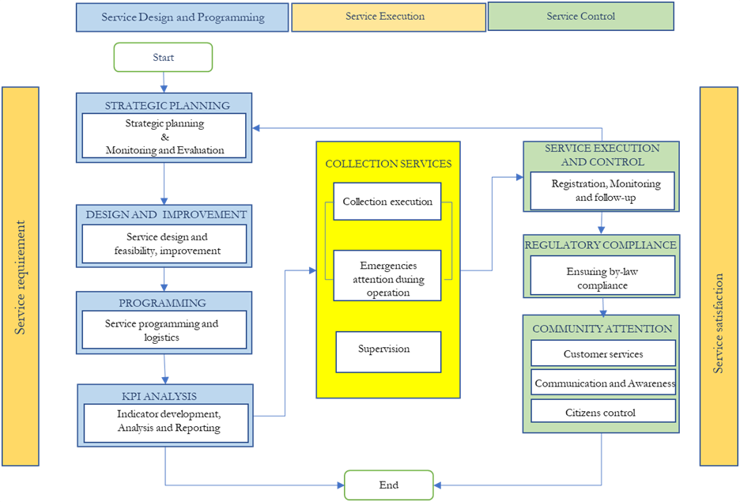

## **3.3. Task 3: Draft Services Framework:** The consultant, based on projected future service needs, in Dar es Salaam will propose a draft service framework plan that will identify, define the service models and scale and phasing of the upgrading, expansion or introduction of DLA services into the future. The draft plan will form a basis for a more detailed analysis that will lead to the development of a detailed services plan.

## **Service Needs into the Future:** The consultant will review existing data on population, business and other waste generators as well as studies and plans projecting urban infrastructure and public space development and make projections by ward using census, building footprint or other method to project growth by ward. The consultant will combine this data to project into the future by ward:

* Waste quantity generated by source and per capita per day.
* Waste composition at the source of generation and at various points of existing collection and transfer and disposal.
* Waste quantity and composition projection for the project timeline.
* Anticipated urban public space (roads, public spaces, beaches, etc.) that may need cleaning services.

**Draft Services Framework:** Drawing upon the identified service gaps in the previous phase, the consultant will define a draft service framework. The draft service framework will form a basis for detailed analysis, verification and elaboration in subsequent tasks.

Following a comprehensive assessment of existing services within the five Dar es Salaam local governments, the consultant shall develop/recommend the set of new/improved services provided or planned to be provided in the DLAs jurisdiction. The Consultant shall define the scope and characteristics of services recommended.

The consultant shall develop the new services considering market factors such as customer demands, population growth, geographic expansion, and anticipated waste generation rates. Additionally, recommendations from other ongoing DMDP Phase 2 studies, including the Institutional Arrangements for Solid Waste Operations and Maintenance and the Dar es Salaam large infrastructure development studies, shall be incorporated into the design process.

The proposed services framework should provide a summary of the services to be provided, basic information on the administrative, operational and financial models to be employed and will include a draft plan for phasing of implementation including timing of introduction of services, timing of expansion of coverage taking into account preliminary cost estimates.

The draft Service Framework should be presented in a consultative meeting with the Dar es Salaam Local Authorities. The result will form a basis for further analysis and verification in the subsequent tasks.

### **3.4. Task 3:** **Options and Feasibility Analysis of Proposed Service Framework:** The consultant should undertake an options assessment and feasibility analysis, to identify the best approach, taking into account technical, legal, political, financial, social and environmental factors among other things. As part of this detailed analysis will be required that should cover at least the following aspects:

**Technology, Program and Organizational Options:** For each service, the consultant will review options (known in Tanzania and internationally) for the implementation or upgrading of each service, considering technical approaches for service delivery (e.g., different types of collection service-door to door, communal collection points; recyclable collection and sorting; collection and process of organic waste; manual vs. mechanical cleaning); programs (communication, awareness, corporate, community or household engagement).

**Institutional-Organizational-Legal Arrangements:** For each (directly by the DLA, contracted to private operators, licensed to private operators-including cooperatives, CBOs, and formally recognized individuals or private companies without a contract, or completely privatized with limited oversight). The analysis should be able to assess feasibility and practicalities of implementing such programs and identify what legal arrangements may be needed (by-laws, contracts, agreements) to implement such a program. This should take into consideration the proposed roles and mandates of municipalities, and the inter-municipal solid waste organization.

**Cost of Services Study:**The consultant will undertake a detailed costs analysis of the proposed services into the future and options for financing. This will inform the technical approach, scale and phasing of services, their viability for implementation by the private vs. public sector and potential financing. Specifically, the consultant will:

* Determine the costs associated with implementing existing solid waste and environmental cleaning services by identifying and analysing cost components, including fixed and variable costs, such as labour, equipment, fuel and transportation, disposal, and administrative and overhead expenses.
* The consultant shall establish and compare the costs of different existing service arrangements/models, including curbside collection, door-to-door collection, transfer stations/skips, communal, and other informal/semi-informal systems.
* Establish the costs of new service for all actors, and covering different arrangements/models, such as curbside collection, door-to-door collection, collection equipment options (trucks, Toyos, hand carts), communal skips/collection points with regular cleaning, and other informal/semi-informal systems.

**Service Framework Options and Feasibility Report:**The consultant will summarize the overall analysis of options and feasibility in a report which will provide and justify the proposed approach to delivery of solid waste and cleaning services.

**3.4. Task 4: Detailed Services Plan:** Based on the recommendation of the preceding options and feasibility assessment, the Consultant shall develop a comprehensive service plan for upgraded, new and planned environmental cleaning and solid waste management services for the City of Dar es Salaam. The service plan will provide a detailed blueprint for the services and the systems that support them. It will include the Final Services Framework and Service Delivery System and will form the basis for the implementation of the plan.

**Final Services Framework:** The final Services Framework should detail the services to be provided, and administrative, operational and financial models to be employed and include the plan for phasing of implementation including timing of introduction of services, timing of expansion of coverage.

*Administrative and Organizational Models:* The consultant will detail the administrative and organizational arrangements the new services to be provided. This will include overall administration by the DLA (and any related roles of the inter-municipal solid waste organization or other institutions) and also the administrative arrangements for each service. This includes the roles, responsibilities, organizational structure, and legal instruments. Specifically, the consultant will outline:

For the DLA and other Public Institutions:

* Organizational structure for delivery of solid waste and cleaning services including organogram and roles.
  + List of supporting legal instruments, existing and proposed, including by-laws, permitting, licensing, environmental, service and tariffs.

For each Service:

* Role and responsibilities of DLA, other institutions including the inter-municipal solid waste institution, private sector and informal sector in the administration of the service and a diagram of these role.
* Description of roles of individual municipal staff or units in administration of the service.
* Identification of legal instruments (licensing, contracts, regulations, standards) needed to govern the service including general obligations (financial, technical, other) required of each party.

*Operational models:* The consultant will develop a detailed operational model for each new service developed. This will include technology used, equipment needs and ownership, communication and cooperation arrangements, supervision needs. It will consider variations in delivery modality depending on the geographic area of the city, and any plans for phased implementation of the work. Specifically, it will outline, for each service:

* + Role of DLAs, other institutions including the inter-municipal solid waste institution, private sector and informal sector in the operation of the service and a diagram of this role.
  + Technology and approach to be employed, presented by phase of implementation, geographic area or other aspect that may apply. The consultant does not have to undertake a detailed optimization of collection or cleaning routes.
  + Arrangements for planning, supervision of the service, monitoring and complaints and customer service.
  + Arrangements for communication and awareness.
  + Expected service standards and how included in legal instruments.
  + Specific financial, technical and other obligations of the service operators and how included in legal instruments.

*Financial Models:* The consultant will develop a budget and financing of the DLAs administration, and for each individual service. In particular, the consultant will outline:

* + A comprehensive budget forecast including Capital Expenditure (CAPEX) and Operating Expenses (OPEX) for the DLAs (and other public institutions as needed) covering their role in administration and delivery of services.
  + For each service a realistic budget forecast disaggregating the costs for the public institutions and private sector or other actors involved.
  + For each service, a realistic revenue model forecast including tariffs, and other revenues, disaggregating the costs for the public institutions and private sector or other actors involved.
  + Detailed tariff, licensing fees or financial incentives that should be established to make these services viable.

### **Final Service Delivery System:** The consultant will detail the systems (human resources, information management, communication, decision making, procedures and processes) needed to successfully deliver the services outlined in the Services framework. The approach should be done interactively, be realistic and cost-effective considering the resources and systems found in Tanzania. The systems will be organized in the previously mentioned functional categories of: (i) *Service Planning, Design and Programming*: including adaptation and optimization of services and programming of routes, daily operations, etc.; (ii) *Service Execution* including the actual delivery, maintenance, supervision and attending emergencies; and (iii) *Service Control* including feedback on the services including service outputs, compliance with standards, customer feedback and complaints and awareness.

For each service and as applicable for overall management, the consultant will develop diagrams (see example below) summarizing separately the functions, staffing, decision making, information and communication, and other system processes or resource needs for each element. The consultant would provide a more detailed description of the same along with a list of the procedures and protocols needed. This would form the basis for the next task which would elaborate these into implementable documents.

**Action Plan:**The consultant will outline a detailed action plan for implementation of the Services Plan including actions, timeline, roles and responsibilities, benchmarks and indicators covering all elements of adopting and implementing the service. This will form a basis for the next step which would elaborate, adopt and implement the services and systems.

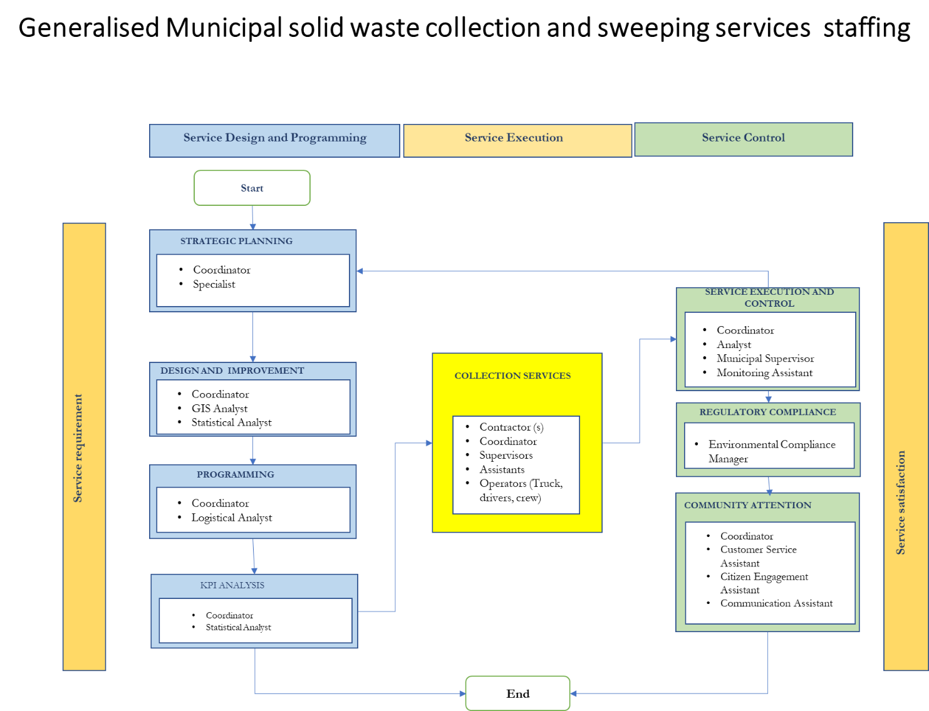

### **3.5. Task 5: Drafting of Enabling Documents for Services**

**Legal, Contractual and Agreements:** Based on the list in Task 5, the consultant will draft the necessary by-laws, contract templates, agreements, licensing arrangements and other legal instruments for implementation of the service plan.

### **Fees, Tariffs, Budgeting and Billing/Collection System:** Based on what was identified in Task 5, the consultant will formalize the process for setting feeds and tariffs and budget allocations as well as the billing and collection. They would also support the government in establishing the initial levels of fees, tariffs, and budget allocations through using the appropriate documentations and processes and consistent with the legal, contractual and agreements drafted under the previous task.

### **Staffing, Job Descriptions:** The consultant would identify the staffing, and develop job description and qualifications for each position that can be subsequently used for formalizing job roles, and filling positions as needed.

### **Procedures and Protocols:** The consultant will need to develop standard operating procedures (SOPs) and any complementary protocols covering the functions outlined in Task 5 for each service. Generally, they shall cover the following minimum elements where applicable:

* Operational planning
* Control, supervision and quality control of services
* Service monitoring and reporting
* Service management including work orders.
* Route planning and monitoring
* Supervision and control of preventive maintenance and repair of assets
* Inventory management system
* Capital investment planning
* Budgeting for operations
* Tariff setting, billing and collection system
* Human resource management and planning
* Consumer service and communications.

**Communications Plan:** The consultant will consolidate the communications related elements of the service delivery system and develop a communication strategy to improve the communication within the local government, with the community, waste generators and with external stakeholders, evaluating their effectiveness in information dissemination and response to inquiries.

**Information Management Plan:** The consultant will assess the needs and information requirements and recommend appropriate information management system including IT solutions to support the efficient implementation and management of waste management and cleaning services in Dar es Salaam.

Specifically, the consultant shall;

* Review the current IT systems available in the DLAs.
* Conduct a comprehensive assessment of the information needs of the Dar es Salaam Local Government authorities needed to support its solid waste management operations.
* Identify key processes and procedures requiring information system support.
* Evaluate existing information systems and data management practices.
* Develop a detailed information requirement specification (IRS) outlining the data elements, data sources, and data flows necessary for effective service delivery.
* Develop a term of reference for a consultant to develop the necessary IT system for implementation.

### **Equipment Specifications**: The consultant will develop the specifications for equipment needed by the DLAs to fulfill their role in the service framework and implement the service systems proposed under task 5. These will include collection, cleaning or other waste management equipment (Bins, sorters, etc.); IT equipment and other equipment (office equipment, etc.). The specifications should be adequate for bidding.

**3.6. Task 6: Adoption and Implementation Advice:**

Following on from the previous tasks, the services plan will be implemented by the DLAs with technical and advisory support of the consultant.

**Introducing Services and Adopting Systems:**This includes adoption of the legal instruments, procedures and protocols, strategies; hiring of staff, procurement of equipment. It will also implement capacity development to enable service adjustments and allow full compliance with the SOPs. Theoretical training, coaching, and on-the-job training shall take place in accordance with the services plan with clear indicators measuring advancement in skills and commitment. Dividing and customizing the training material and topics per staff category within a given facility or service which shall be developed carefully to ensure maximum dissemination of knowledge; that head of departments will act as natural participants in all respective training so they can take over monitoring and evaluation, and provide same training if necessary to their subordinates.

**Monitoring and Review:**Under this task, the Consultant will perform periodic review to DLAs performance and compliance with SOPs, and introduce changes that would improve the performance. It is envisaged that the presence of the Consultant under earlier tasks will be intense, then gradually withdraw to a periodic presence under this task

1. **Deliverables:**

## **Inception Report:**

The Consultant shall submit within two weeks after contract commencement, an inception report which should, inter alia, include:

* Detailed description of approach to work and of specific assignment to be covered;
* Detailed work schedules;
* Detailed organizational and staffing structures showing staff deployment and sub-division of work between the field and home office;

## **Baseline Report:**

The Consultant shall submit within six weeks after contract commencement, a summary report which should, inter alia, include:

* Data and document review;
* Completion of survey of solid waste services.
* Completion of cost survey.

## **Assessment of Existing Solid Waste Services:**

The Consultant shall submit within ten weeks after contract commencement, an assessment of existing solid waste services, inter alia, including:

* Assessment of the Existing Services Framework.
* Assessment of the Existing Service Delivery System.

## **Draft Service Framework:**

The Consultant shall submit within ten weeks after contract commencement, the Draft Services Framework.

## **Service Framework Options and Feasibility Report**

The Consultant shall submit within fifteen weeks after contract commencement, the Service Framework Options and Feasibility Report.

## **Detailed Services Plan:**

The Consultant shall submit within fifteen weeks after contract commencement, the detailed Services Plan including the Final Service Framework and Final Service Delivery System

**4.7 Enabling Documents for Services Plan**

The Consultant shall submit within twenty weeks after contract commencement, the enabling documents for the Services Plan including:

* Legal, contracts and agreements.
* Fees, tariffs and budgeting as well as billing and collection system.
* Procedures and protocols
* Communications plan
* Information management plan
  1. **Adoption and Implementation of the Services Plan**

The Consultant shall submit final report of the assignment which shall include progress report for the implementation of the Services Plan from contract commencement. The implementation period for the Service Plan shall be 12 months after its adoption. The report shall follow a well-designed template approved by the Client and shall reflect the progress of service plan activities including performance M&E, follow-up, in addition to dashboard indicating staff & equipment performance through the reporting period, and indicate areas of success and areas requiring reinforcement by additional training or resources. Also, the report shall reflect the following:

* Assessment of progress made versus set targets; status of performance indicators;
* Recommendations on steps to be taken in case targets are not achieved or will have to be rescheduled;
* Attendance sheets.
* Feedback by trainees;
* Pre and post training evaluation; field observation in the field;
* Photographic record.

# Duration of Assignment

The consultancy service is expected to be completed within 20 months, from commencement of the contract, which include 8 months for preparation of service plan and 12 months for monitoring implementation of the service plan.

# Qualification Requirements

## **Experience of the Firm:**

At least 10 years of experience in activities related to the operation, capacity building, and institutional strengthening of public or private institutions in charge of service provision in the Solid Waste Management Sector.

## **Specific Experience of the Firm:**

* Experience in institutional strengthening and technical assistance for local governments.
* Experience in planning, organization and Management of activities concerning municipal services.
* Experience in the construction of indicators and activities of monitoring and evaluation of results.
* Experience in capacity building and transfer of knowledge to people in charge of public services preferably municipal services.
* Experience in promoting the active participation of a population in the execution of investment projects.
* Experience in the design and application of strategies to improve the collection of tariffs for municipal revenues;
* Experience in the formulation and/or execution or supervision of public projects with an emphasis on solid waste and sanitation.
* Experience in the utilization of software and information technology in the context of public/municipal services.

## **Key Staff:**

The consultant’s team shall include the following minimum key-staff:

* Team Leader/Project Manager;
* Operations Engineer 2 Nos.;
* Solid Waste Management Expert;
* Environmental and Safety Engineer;
* Financial Analyst;
* Human Resources Expert;
* Draughtsman/Illustrator

## Key-Staff Qualifications, Work Experience and Inputs:

The Consultant’s time input for key staff, including short-term professional staff, is estimated to be approximately 71 person-months for the whole duration of the assignment, but the Consultant may suggest, as per his judgment, the level of time input necessary to adequately meet the requirements of this TOR, consistent with the technical proposal. Further, staff input should be separately and adequately estimated and clearly provided for in the technical and financial proposals, respectively, to ensure proper and successful implementation of the assignment. Input for non-key experts is limited to approximately 10 person-months.

**Table (2): Qualifications, Experience and Inputs Requirements**

| **S/N** | **Specialists** | **Responsibilities** | **Qualifications and Work Experience:** | **Inputs**  **(Person-Month)** |
| --- | --- | --- | --- | --- |
|  | **Team Leader** | * Overall project coordination and management * Stakeholder engagement and communication * Resource allocation and budget management * Reporting and documentation | * Minimum BSc degree in engineering and MSc in Public Administration or Management or Economics from accredited university; * At least 20 years of work experience of which 12 years in leading positions or as chief operator of major solid waste management facility; * He/She should have an experience of working in developing countries and possess excellent communication skills to effectively interact with clients, team members, regulatory agencies, and other stakeholders. | 12 |
|  | **Operations Engineer (2 No.)** | * Designing and optimizing waste management operations * Overseeing logistics and transportation * Implementing operational efficiency measures * Quality control and performance monitoring | * Minimum BSc degree in mechanical or industrial or civil engineering from accredited university with at least 15 years’ experience in operational planning and execution of which 7 years at least in the municipal solid waste management sector; * He/She should have an experience of working in developing countries and possess excellent communication skills to effectively interact with clients, team members, regulatory agencies, and other stakeholders. | 24 |
|  | **Solid Waste Management Expert** | * Developing waste management strategies and policies * Conducting waste audits and analysis * Providing technical guidance on waste treatment processes * Capacity building and training. | * Minimum BSc in Environmental or Civil Engineering from accredited university, master’s degree is desirable. * At least 12 years’ experience of which 7 years at least in the municipal solid waste management sector;   He/She should have an experience of working in developing countries and possess excellent communication skills to effectively interact with clients, team members, regulatory agencies, and other stakeholders. | 12 |
|  | **Environmental and Safety Engineer** | * Assessing environmental impacts and risks * Ensuring compliance with safety regulations * Implementing pollution control measures * Environmental monitoring and reporting | * Minimum BSc degree in Environmental Engineering or related field from accredited university; Master’s degree is desirable. * At least 10 years of practical experience in the field of environmental engineering management and safety, with proven experience in the environmental monitoring and mitigation within the solid waste management sector; * He/She should have an experience of working in developing countries and possess excellent communication skills to effectively interact with clients, team members, regulatory agencies, and other stakeholders. | 7 |
|  | **Financial Analyst** | * Financial planning and cost analysis * Budget development and evaluation * Financial forecasting and risk assessment * Monitoring project expenditures | * Minimum a Bachelor's degree in Finance, Economics, Business Administration, or a related field is essential. A Master's degree in Finance or a relevant field would be an added advantage. * At least 15 years of experience in financial analysis, budgeting, financial modelling, and forecasting is crucial. Experience in working with local government entities or waste management projects would be highly beneficial. * Understanding of local government structures, policies, and regulations related to waste management services in Dar es Salaam is essential. * Proficiency in financial analysis tools, software, and databases to conduct in-depth financial analysis and modelling. * He/She should have an experience of working in developing countries and possess excellent communication skills to effectively interact with clients, team members, regulatory agencies, and other stakeholders. | 7 |
|  | **Human Resources Expert** | * Workforce planning and recruitment * Training and skills development programs * Performance management and employee relations * Ensuring compliance with labuor laws | * Minimum BSc degree in Human Resources Management (HRM) or Public Administration, or Business Administration from accredited University; Master’s degree is desirable. * At least 15 years of practical experience in the HR field with minimum of 5 years in HRM for public utilities; * He/She should have an experience of working in developing countries and possess excellent communication skills to effectively interact with clients, team members, regulatory agencies, and other stakeholders. | 4 |
|  | **Draughtsman/Illustrator** | * Creating visual aids and illustrations for project documentation * Drafting technical drawings and schematics * Supporting the design and presentation of project plans | * Minimum 2 years diploma in engineering drafting, graphic design, and material reproduction. * At least 5 years of practical experience in designing illustrative boards, reports, templates, facility layouts, and manuals; * Proven Experience in Autodesk® AutoCAD, Adobe Photoshop, and Adobe® Illustrator or Coral Draw®, expertise in Autodesk Civil 3d® is a plus; * He/She should have an experience of working in developing countries and possess excellent communication skills to effectively interact with clients, team members, regulatory agencies, and other stakeholders. | 5 |
|  | **Total** | | | **71** |

**Summary of Indicative Staff Input (Person-Months)**

|  |  |  |  |  |
| --- | --- | --- | --- | --- |
|  |  | **Service Plan Preparation** | **Service Plan Implementation** | **Total** |
| **S/N** | **Item Description** | **Person-Month(s)** | **Person-Month(s)** |  |
| **A** | **Key Personnel** |  |  |  |
| 1 | Team Leader | 8 | 4 | 12 |
| 2 | Operations Engineer (2 Nos.) | 16 | 8 | 24 |
| 3 | Solid Waste Management Expert | 8 | 4 | 12 |
| 4 | Environmental and Safety Engineer | 5 | 2 | 7 |
| 5 | Financial Analyst | 5 | 2 | 7 |
| 6 | HR Expert | 3 | 1 | 4 |
| 7 | Draughtsman/Illustrator | 5 | 0 | 5 |
|  |  | **50** | **21** | **71** |
| **B** | **Non-Key Experts/Short Term Experts** |  |  |  |
| 1 | GIS Expert, Data Analyst, Sociologist, etc. | 10 |  | **10** |

# Payment Schedule

The contract for the assignment will be a lump-sum contract payment percentage against submitted and accepted deliverables, as per the following disbursement schedule:

Payment (1): Fifteen percent (15%) upon signing of contract, after submission of acceptable advance payment bank guarantee

Payment (2): Ten percent (10%) of the contract amount shall be paid upon the submission of the **Inception Report** (deliverable 4.1) acceptable by the Client.

Payment (3): Fifteen percent (15%) of the contract amount shall be paid upon the submission of the **Baseline Data, Assessment of Existing Solid Waste Services and Draft Services Framework** (deliverables 4.2, 4.3 and 4.4) acceptable by the Client.

Payment (4): Twenty- percent (20%) of the contract amount shall be paid upon the submission of the **Service Options and Feasibility Report and Detailed Services Plan** (deliverable 4.5 and 4.6) acceptable by the Client.

Payment (5): Twenty percent (20%) of the contract amount shall be paid upon the submission of the **Enabling documents for the Services Plan** (deliverable 4.7) acceptable by the Client, directly reflecting the equal percent of performance indicators global rating.

Payment (6): Twenty percent (20%) of the contract amount shall be paid upon the submission of the **Final Report** (deliverable 4.8) acceptable by the Client, related to the adoption of the enabling documents; and directly reflecting the equal percent of performance indicators global rating.

**Table 3: Payment Modalities Summary**

| **S/N** | **Deliverable** | **Payment (%)** |
| --- | --- | --- |
| 1 | Upon Signing of Contract, after submission of acceptable Advance Payment Bank Guarantee | 15% |
| 2 | Inception Report acceptable to the Client (4.1) | 10% |
| 3 | Baseline Data, Assessment of Existing Solid Waste Services and Draft Services Framework (4.2, 4.3 and 4.4) acceptable by the Client. | 15% |
| 4 | Service Options and Feasibility Report and Detailed Services Plan (deliverable 4.5 and 4.6) acceptable by the Client | 20% |
| 5 | Enabling documents for the Services Plan (deliverable 4.7) acceptable by the Client | 20% |
| 6 | Final Report (deliverable 4.8) acceptable by the Client | 20% |

1. **Contractual Arrangements**:

The selected consultancy firm or individual consultant will enter into a formal contract with the PO-RALG Project Coordination Team (PCT) for DMDP 2 outlining the terms and conditions of the consultancy service.

1. A pre-feasibility study covering legal, financial and organizational considerations was undertaken to identify the institutional approach. The institution is proposed to be a public company owned by the Dar es Salaam Local Authorities through an inter-municipal organization. It would have the mandate to operate those services with facilities shared among municipalities (transfer and transfer, disposal, centralized sorting of recyclables and composting) through private sector contracts, undertake planning and establish standards, tariffs and provide capacity building to the Dar es Salaam Local Government Authorities.
2. The Dar es Salaam City Master Plan (2016-2036) identified four landfill sites for development and proposed they be combined with transfer stations and recycling/composting facilities. A preliminary analysis conducted during project preparation supports the proposal that a combination of transfer stations, recycling/composting facilities and multiple landfills will provide an integrated solid waste management system that will help overcome the transport limitations currently affecting waste collection and disposal services in Dar es Salaam. Before selection of sites for investment, an assessment of site suitability and transport costs and GHG emissions will be completed using the landfill sites proposed in the Master Plan and additional sites identified sites.
3. A self-organized group of 500 people work collecting recyclables on the Pugu dumpsite, many of which live near the dumpsite. A livelihood program will be developed for these groups as part of the project. Informal recyclers also productively work on the street of Dar es Salaam collecting bottles and other items of value. The collection and recycling system will be designed to incorporate them and their important role in the solid waste system in the city. This will be done in coordination with ongoing initiatives by the government and NGOs on registering informal waste collectors.
4. Intermunicipal solid waste institution feasibility study for Dar es Salaam, 2021